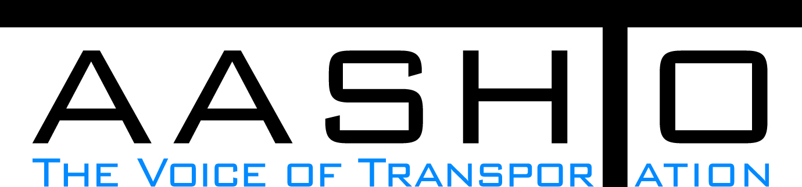Domestic Scan Proposal Form
AASHTO is soliciting topic proposals for a Calendar Year 2014 US Domestic Scan Program (NCHRP Panel 20-68A). Each selected scan topic will be investigated through site visits to three to six locations for approximately a two week period or less (type 1), by webinar, (type 2) peer exchange, or (type 3) conducted by a group of eight to 12 transportation professionals with expertise in the selected topic area. Proposed topics should meet the following criteria:
- Address an important and timely need for information by transportation agencies;
- Are of interest to a broad national spectrum of people and agencies;
- Are complex and also “hands-on,” meaning they lend themselves particularly well to exploration through on-site visits; and
- Are sufficiently focused that the tour participants are able to investigate and understand key issues in the limited time available on the tour.

Before submitting your proposal it is highly recommended that you read What Makes a Good Scan Topic Proposal http://www.domesticscan.org/what-makes-a-good-scan-topic-proposal
This form is designed to collect the full length of your proposal. Sections requiring essays have unlimited space for you to use. Contact information has some limited text. Use your TAB→ key to advance to the area where you need to complete information.
Proposals should be returned no later than OCTOBER 15, 2013.
IMPORTANT NOTE on How to save your document: LastNameFirst Initial, underscore_Organization Acronym _CY2014.
Saved Document Name Example: VitaleM_AASHTO_CY2014
If you have more than one, add a number after first initial: VitaleM1_AASHTO_CY2014

Domestic Scan Proposal Contact Information
Name | ERIC PITTS | Address | 935 E. Confederate Avenue  Building 24, Room 405  Atlanta, GA 30316-2531
Title | Chief Maintenance Engineer | E-mail | Eric.pitts@dot.state.ga.us
Member Department | Georgia DOT | Telephone number | (404) 631-1387
AASHTO Committee | SCOM | Date of submission | October 15, 2013

Title of Proposed Scan: Best practices in determining funding levels for maintenance and preservation

Problem Statement (What topic is to be examined? What drives the need for the scan? Why now?)
The purpose of this scan is to indentify funding allocation practices that support the delivery of efficient and effective maintenance programs.
At the 2013 AASHTO SCOM meeting, a quick survey was done at the Pavement Technical Working Group break out session, asking the states to name the most pressing issues they are facing with. Securing adequte funding was listed by a majority of states and emerged as the most common issue.
Funding is more than an issue between legislative bodies and the DOTs. There are internal considerations within agencies that impact the funding received by the maintenance divisions in the DOTs. This scan will assist in determining best practices that may be emulated by additional DOTs to secure the needed funding for their assets.
This topic is critical as the current highway bill, MAP-21 creates a streamlined and performance-based surface transportation program that aims for the state of good repair; long term Federal funding is uncertain, DOT gas tax revenues are generally declining, and the aging infrasture is continuing to deteriorate and is in need of adequate maintenance.

Scan Scope (What specific subject areas are to be examined? Which cities and states might be visited? Which agencies/organizations (including specific departments or types of staff if applicable)?
The following subject areas will be examined among transportation agencies that have been succcessful at maintaining or increasing their highway maintenace funding, and to identify successful best practices in funding allocation processes:
1) How do agencies determine funding for statewide maintenance and preservation?
2) How do agencies allocate funding for districts and regions?
3) How do districts/ regions allocate funding for specific maintenance tasks?
4) How do agencies measure their effectiveness with the budgets that they receive, and how do they determine the optimal budgetary allocations?
5) What performance measures have been successfully implemented to improve the budgetary obligations provided for maintenance, and how do the performance measures link to funding allocations?

A domestic scan could help identify the methods by which transporatation agencies perform this budgetary process, and identify successful practices that can be adopted by other agencies:
a) who is involved in the budgetary decision making process,
b) differing budget levels ($/lane-mile) and differing staffing levels (miles of roads maintained/maintenance worker) that result from the different budgetary methods that are used,
c) GASB-34 use with the DOTs and other agencies,
d) common data requirements,
e) management systems and their use in this decision making process,
f) performance measures,
g legislative requirements,
h) trends in changes of maintenance funding, etc.

Proposed agencies/ organizations to visit:
1) Washington DOT
2) North Carolina DOT
3) Bay Area Metropolitan Transportation Commission
4) Alabama DOT
5) Mississippi DOT
6) Kansas DOT
7) Tennesse DOT
8) APWA (Public Works Certification Staff)

Anticipated Scan Results (What key information is to be gained? What information is to be shared after the scan? Who would the audience be for this information?)
Based on the domestic scan information gathering process, the scan team should then make recommendations on the best practices to achieve adequate funding for maintenance – particularly the who, what, when, where, and how to implement the recommended best practices in the budgetary process.

Benefits Expected (Including potential impacts on current technology or procedures)
States may adopt new budgetary processes that are succesful in securing adequte funding for effictive and efficient maintenance and preservation programs.

